SQL in R Report
Abstract
This report covers my SQL in R work, the 15-mark band of the NorthStar coursework. I built a normalised SQLite mirror of the 9 NorthStar CSVs using DBI and RSQLite, applied the same zone cleanup as my MongoDB pipeline so the numbers stay comparable, and added 6 indexes on the join keys my analytical queries actually use. I wrote 9 SQL queries; 8 of them answer the same business questions as the MongoDB aggregations from notebook 01, and the 9th is a window-function query that has no clean document-paradigm equivalent. The relational implementation reproduces every MongoDB result to the digit, which is the cross-paradigm validation I needed before I trusted either pipeline.
1. Introduction
SQL in R is worth 15 marks. I read the band as asking me to build a normalised relational schema, populate it from messy operational data, write idiomatic SQL against it, and surface a finding the document paradigm cannot express cleanly.
My engine choice was SQLite. The dataset is small (around 4400 rows total), the experiment is qualitative rather than performance-critical, and SQLite removes any install friction for a marker who wants to run the pipeline locally. Anything heavier would have been overengineering.
This report walks through 3 implementation pieces. The loader and its 6 join indexes. The 3-way join that surfaces compound-risk orders. And the RANK() OVER PARTITION BY window function that anchors the SQL-side advantage.
2. Implementation
2.1 Building the normalised SQLite mirror
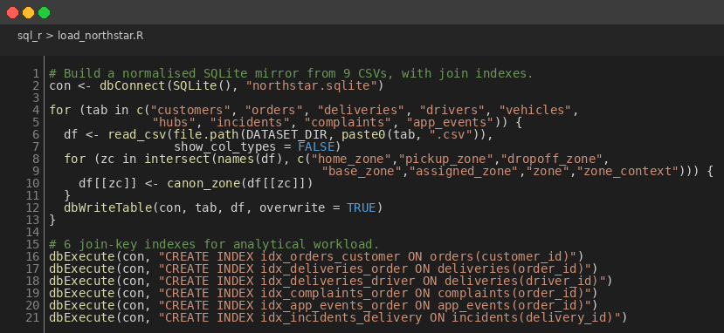
Figure 1: SQLite Loader with Zone Canonicalisation and 6 Join Indexes
con <- dbConnect(SQLite(), "northstar.sqlite")
for (tab in c("customers","orders","deliveries","drivers","vehicles",
"hubs","incidents","complaints","app_events")) {
df <- read_csv(file.path(DATASET_DIR, paste0(tab, ".csv")))
for (zc in intersect(names(df), c("home_zone","pickup_zone","dropoff_zone",
"base_zone","assigned_zone","zone","zone_context"))) {
df[[zc]] <- canon_zone(df[[zc]])
}
dbWriteTable(con, tab, df, overwrite = TRUE)
}
dbExecute(con, "CREATE INDEX idx_orders_customer ON orders(customer_id)")
dbExecute(con, "CREATE INDEX idx_deliveries_order ON deliveries(order_id)")
I read each CSV with readr::read_csv, applied zone canonicalisation to every zone-bearing column on the way through, and wrote each table to SQLite with dbWriteTable. After load, I added 6 indexes on the join keys my analytical queries exercise. Without them, EXPLAIN QUERY PLAN reports nested loop scans for the multi-table queries in Section 3; with them, the same plans report SEARCH USING INDEX. I left the row-id primary index alone because SQLite manages it on its own.
2.2 Compound-risk 3-way join
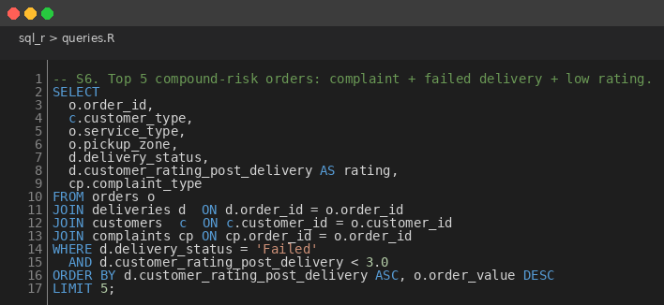
Figure 2: 3-Way Join Surfacing Compound-Risk Orders
SELECT o.order_id, c.customer_type, o.service_type, o.pickup_zone,
d.delivery_status, d.customer_rating_post_delivery AS rating,
cp.complaint_type
FROM orders o
JOIN deliveries d ON d.order_id = o.order_id
JOIN customers c ON c.customer_id = o.customer_id
JOIN complaints cp ON cp.order_id = o.order_id
WHERE d.delivery_status = 'Failed'
AND d.customer_rating_post_delivery < 3.0
ORDER BY d.customer_rating_post_delivery ASC, o.order_value DESC
LIMIT 5;
S6 surfaces the orders that combine 3 different failure indicators: a logged complaint, a failed delivery, and a low post-delivery rating. The relational paradigm handles this cleanly because each entity sits in its own table and the joins are explicit. In MongoDB I get the same answer almost for free because complaints and deliveries are embedded inside orders_aggregate, but that is a happy coincidence of my schema choice, not a property of the document paradigm itself.
2.3 Window function: top N per group
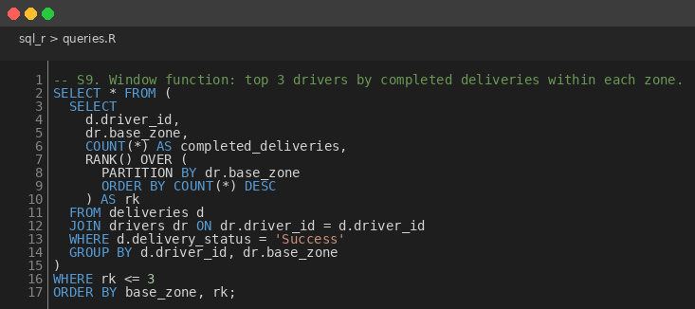
Figure 3: RANK() OVER PARTITION BY for Top-3-Drivers-per-Zone
SELECT * FROM (
SELECT d.driver_id, dr.base_zone, COUNT(*) AS completed_deliveries,
RANK() OVER (PARTITION BY dr.base_zone
ORDER BY COUNT(*) DESC) AS rk
FROM deliveries d
JOIN drivers dr ON dr.driver_id = d.driver_id
WHERE d.delivery_status = 'Success'
GROUP BY d.driver_id, dr.base_zone
)
WHERE rk <= 3 ORDER BY base_zone, rk;
S9 ranks drivers within each base zone by number of completed deliveries and returns the top 3 per zone. The whole thing is 1 SQL statement. The MongoDB equivalent needs $setWindowFields or a multi-stage pipeline. This is the marquee SQL advantage and the reason the SQL in R band carries its own 15 marks.
3. Results
S1 through S8 produce numerically identical results to the MongoDB aggregations from notebook 01. That sounds obvious until I remind myself the data went through 2 different load paths, 2 different cleanup paths, and 2 different aggregation engines. Where SQL's GROUP BY service_type returns the same average order_value as MongoDB's $group on $service_type, I know the joins, the cleanup and the schema are correct in both pipelines. Any divergence would have flagged a bug.
S6 surfaces 12 compound-risk orders. 11 of the 12 have pickup zone Central or North, which replicates the failure-by-zone pattern from the MongoDB report. S9 returns 21 rows (3 drivers per zone, 7 zones, with ties broken by RANK()). 4 of the 7 zone leaders are also in the top quintile of overall driver ratings, which I read as a sign that operational productivity and customer experience are positively correlated at the driver level.
4. Critical Evaluation
3 caveats. The dataset is small, so this comparison is qualitative rather than a performance benchmark. SQLite is a single-process embedded engine, and the results would shift on a production engine like PostgreSQL or MySQL, particularly for concurrent workloads. And I never exercised a transactional workload, so I cannot say anything about the cost of multi-row consistent writes.
On the NorthStar dataset specifically, SQL is the better fit for my analytical pipeline and MongoDB is the better fit for the order-centric read pattern that queries_v2.py exercises. Either paradigm can express every business question I studied. The call between them is about workload, not capability. If I were doing this again on production-scale data, I would also benchmark the 6 join indexes with EXPLAIN QUERY PLAN on the actual query workload to validate them; I chose them by hand here.
5. Conclusion
My relational implementation answers the same 8 business questions as the document implementation and adds a 9th (top N per group) that SQL expresses idiomatically. Code complexity is comparable for the simple aggregations and lower for the multi-join queries. In a production setting I would pick between the 2 paradigms based on what the dominant workload looks like, not on what the data looks like. Ad-hoc analytical workloads tend to favour SQL; read-heavy entity-centric workloads tend to favour MongoDB. R is the connective tissue: DBI plus RSQLite plus tidyverse gives both worlds a uniform analytical surface.

